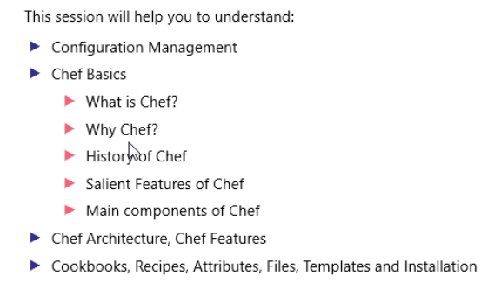

Coloration b/w teams.

There are different ways infrastructure is looked at.

- Virtualization:   
Transformed idea of machines as a set of files.

Virtualization is way of **handling machines** **programmatically** (sysadmin)

Collaboration b/w Ops & developers

We can describe Infrastructure as code.. Software defined infrastructure..

[root@devosp1 Downloads]# su vobadm

[vobadm@devosp1 Downloads]$ sudo rpm -ivh '/media/sf_C_DRIVE/Users/vebalusu/Downloads/supermarket-3.0.2-1.el6.x86_64.rpm'

warning: /media/sf_C_DRIVE/Users/vebalusu/Downloads/supermarket-3.0.2-1.el6.x86_64.rpm: Header V4 DSA/SHA1 Signature, key ID 83ef826a: NOKEY

Preparing... ########################################### [100%]

1:supermarket ########################################### [100%]

Thank you for installing Supermarket!

The next step in the process is to run:

supermarket-ctl reconfigure

[vobadm@devosp1 Downloads]$ supermarket-ctl reconfigure